* **Descrizione Studio scelto**

Per questo esame ho deciso di portare in relazione tutti gli acquisti di N Soci appartenenti alla stessa cooperativa. La cooperativa di riferimento si occupa di acquistare bevande di qualsiasi tipo per poi rivenderli esclusivamente ai propri soci a prezzi adeguati. L’analisi in questione è orientata prevalentemente ad analizzare, in un determinato anno, i prezzi di acquisto di un determinato prodotto che i soci acquistano da altri fornitori. Questo tipo di analisi consentirà poi alla cooperativa di lanciare sul mercato un prodotto simile al prodotto analizzato ad un prezzo competitivo o inferiore. Questa attività è possibile principalmente per due motivi:

1 i dati di acquisto vengono passati mensilmente dai soci alla cooperativa che a sua volta li organizza in diverse tabelle specifiche;

2 viene effettuata una procedura di trascodifica dei prodotti per unificare il codice da analizzare in quanto il codice passato dal socio è diverso da quello della cooperativa.

* **Progettazione**

Entity

Socio : Azienda con P.IVA che acquista prodotti dalla cooperativa o da altri fornitori

Product : Prodotti acquistati dai soci

Supplier : Aziende con P.IVA che vendono i prodotti ai soci

OrderHeader: Richiesta di acquisto di un socio ad un fornitore per uno o piu’ articoli.

OrderDetail : Singola transazione di acquisto ognuna della quale viene specificato il prodotto, fornitore, quantità e prezzo a cartone.

Attributi

Socio: IdSocio (PK), Ragione Sociale, Regione, Numero di Telefono, P_IVA

Product: IdProdotto (PK), Descrizione, QxC (Quantità x Confezione), Categoria

Supplier: IdSupplier (PK), Ragione Sociale, P_IVA

OrderHeader: OrderID (PK), OrderDate, idFornitore (FK), IdSocio (FK), Anno

OrderDetail : OrderID (PK), LineItemNo (PK), IdProduct (FK), Quantity, Prezzo

Relazione (Almeno 5)

1. Un socio (Socio) può fare diversi acquisti (OrderHeader) 1🡪N
2. L’acquisto (OrderHeader) può essere fatto da un singolo socio (Socio) 1🡪1
3. Un ordine (OrderHeader) può contenere piu’ righe di acquisti (OrderDetail) 1🡪N
4. Una singola transazione (OrderDetail) si riferisce a un singolo ordine (OrderHeader) 1🡪1
5. Un articolo (product) può essere acquistato da fornitori diversi a diversi prezzi per cui è presente in piu’ transazioni (OrderHeader) 1🡪N
6. Una singola transazione (SalesDetail) può riferirsi a un singolo prodotto (Product) 1🡪1
7. Un fornitore (Supplier) può essere presente in piu’ ordini (OrderHeader) 1🡪N
8. Per un ordine (OrderHeader) può corrispondere un solo fornitore (Supplier) 1🡪1

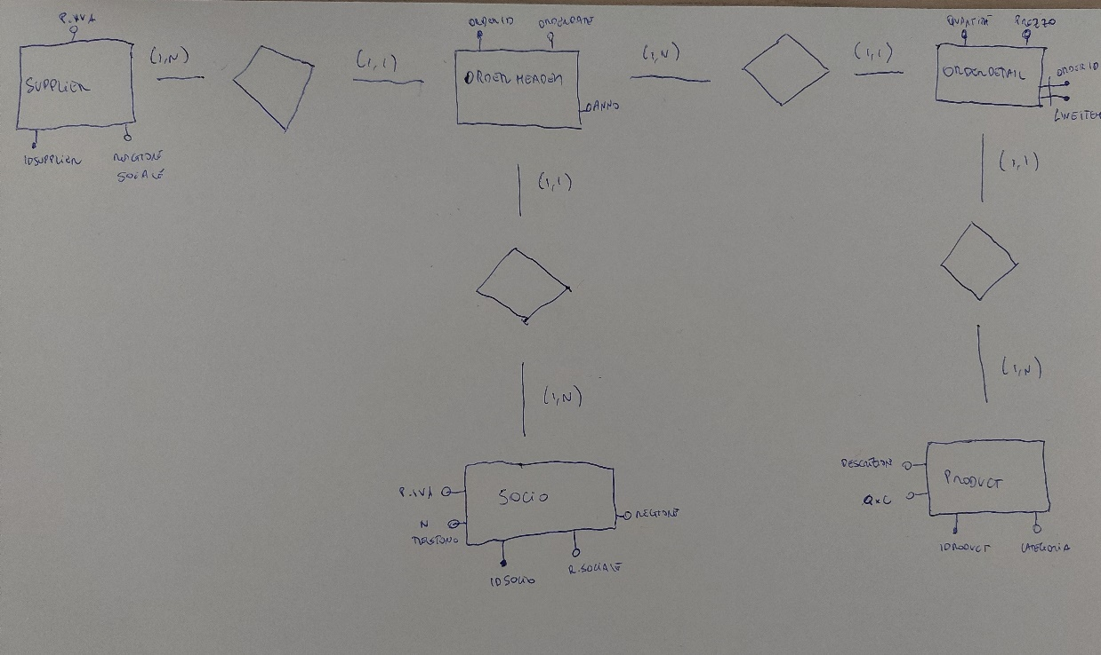

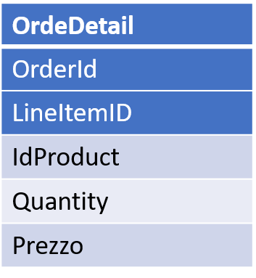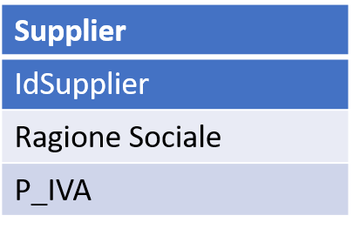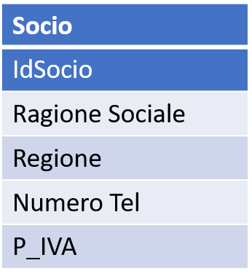

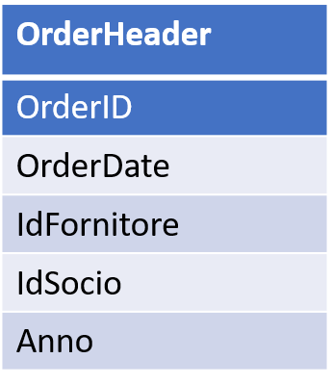

*La Partita IVA dei fornitori non è stata inserita per dimenticanza mia.

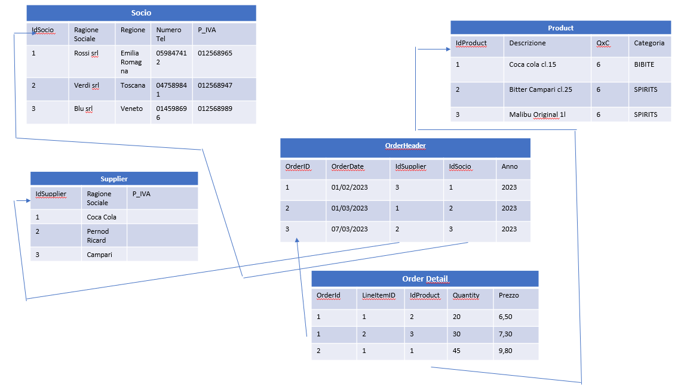

CREATE TABLE [dbo].[Product](

[IdProduct] [int] NOT NULL default 0,

[Descrizione] [varchar](50) NOT NULL default ‘’ ,

[QxC] [int] NOT NULL default 0,

[Categoria] [varchar](50) NOT NULL default ‘’,

CONSTRAINT [PK_Product] PRIMARY KEY (IdProduct))

CREATE TABLE [dbo].[Socio](

[IdSocio] [int] NOT NULL default 0,

[Ragione Sociale] [varchar](50) NOT NULL default ‘’,

[Regione] [varchar](50) NOT NULL default ‘’,

[Telefono] [varchar](50) NOT NULL default ‘’,

[P_IVA] [varchar](50) NOT NULL default ‘’,

CONSTRAINT [PK_Socio] PRIMARY KEY (IdSocio))

CREATE TABLE [dbo].[Supplier](

[IdSupplier] [int] NOT NULL default 0,

[Ragione Sociale] [varchar](50) NOT NULL ‘’,

[P_IVA] [varchar](50) NOT NULL default ‘’,

CONSTRAINT [PK_Supplier] PRIMARY KEY (IdSupplier))

CREATE TABLE [dbo].[OrderHeader](

[OrderId] [int] NOT NULL default 0,

[OrderDate] [datetime] NOT NULL default ‘19990101’,

[IdSupplier] [int] NOT NULL default 0,

[IdSocio] [int] NOT NULL default 0,

[Anno] [varchar](50) NOT NULL default ‘’,

CONSTRAINT [PK_OrderHeader] PRIMARY KEY (OrderId)

CONSTRAINT [FK_OrderHeader_Supplier_IdSupplier]

FOREIGN KEY (IdSupplier)

REFERENCES Supplier (IdSupplier),

CONSTRAINT [FK_OrderHeader_Socio_IdSocio]

FOREIGN KEY (IdSocio)

REFERENCES Socio (IdSocio))

CREATE TABLE [dbo].[OrderDetail](

[OrderId] [int] NOT NULL default 0,

[LineItemID] [int] NOT NULL default 0,

[IdProduct] [int] NOT NULL default 0,

[Quantity] [int] NOT NULL default 0,

[Prezzo] [money] NOT NULL default 0,

CONSTRAINT [PK_OrderDetail] PRIMARY KEY (OrderId, LineItemId),

CONSTRAINT [FK_OrderHeader_OrderHeader_OrderId]

FOREIGN KEY (OrderId)

REFERENCES OrderHeader (OrderId), 0145897878

CONSTRAINT [FK_OrderHeader_Socio_IdProduct]

FOREIGN KEY (IdProduct)

REFERENCES Product (IdProduct))

USE [ESAME_EPICODE]

GO

INSERT [dbo].[OrderDetail] ([OrderId], [LineItemID], [IdProduct], [Quantity], [Prezzo]) VALUES (1, 1, 63, 10, 12.5000)

GO

INSERT [dbo].[OrderDetail] ([OrderId], [LineItemID], [IdProduct], [Quantity], [Prezzo]) VALUES (1, 2, 75, 5, 10.5000)

GO

INSERT [dbo].[OrderDetail] ([OrderId], [LineItemID], [IdProduct], [Quantity], [Prezzo]) VALUES (2, 1, 15, 9, 17.3000)

GO

INSERT [dbo].[OrderDetail] ([OrderId], [LineItemID], [IdProduct], [Quantity], [Prezzo]) VALUES (3, 1, 2, 45, 10.3000)

GO

INSERT [dbo].[OrderDetail] ([OrderId], [LineItemID], [IdProduct], [Quantity], [Prezzo]) VALUES (4, 1, 60, 12, 25.0000)

GO

INSERT [dbo].[OrderDetail] ([OrderId], [LineItemID], [IdProduct], [Quantity], [Prezzo]) VALUES (5, 1, 20, 3, 21.0000)

GO

INSERT [dbo].[OrderDetail] ([OrderId], [LineItemID], [IdProduct], [Quantity], [Prezzo]) VALUES (5, 2, 23, 26, 32.0000)

GO

INSERT [dbo].[OrderDetail] ([OrderId], [LineItemID], [IdProduct], [Quantity], [Prezzo]) VALUES (5, 3, 26, 44, 58.4000)

GO

INSERT [dbo].[OrderDetail] ([OrderId], [LineItemID], [IdProduct], [Quantity], [Prezzo]) VALUES (6, 1, 39, 40, 12.7000)

GO

INSERT [dbo].[OrderDetail] ([OrderId], [LineItemID], [IdProduct], [Quantity], [Prezzo]) VALUES (6, 2, 40, 25, 4.9500)

GO

INSERT [dbo].[OrderDetail] ([OrderId], [LineItemID], [IdProduct], [Quantity], [Prezzo]) VALUES (7, 1, 74, 50, 7.4500)

GO

INSERT [dbo].[OrderDetail] ([OrderId], [LineItemID], [IdProduct], [Quantity], [Prezzo]) VALUES (8, 1, 12, 77, 6.5200)

GO

INSERT [dbo].[OrderDetail] ([OrderId], [LineItemID], [IdProduct], [Quantity], [Prezzo]) VALUES (9, 1, 59, 71, 12.7000)

GO

INSERT [dbo].[OrderDetail] ([OrderId], [LineItemID], [IdProduct], [Quantity], [Prezzo]) VALUES (9, 2, 58, 52, 21.7000)

GO

INSERT [dbo].[OrderDetail] ([OrderId], [LineItemID], [IdProduct], [Quantity], [Prezzo]) VALUES (10, 1, 10, 63, 20.7000)

GO

INSERT [dbo].[OrderDetail] ([OrderId], [LineItemID], [IdProduct], [Quantity], [Prezzo]) VALUES (11, 1, 69, 41, 4.2100)

GO

INSERT [dbo].[OrderDetail] ([OrderId], [LineItemID], [IdProduct], [Quantity], [Prezzo]) VALUES (12, 1, 70, 25, 9.5000)

GO

INSERT [dbo].[OrderDetail] ([OrderId], [LineItemID], [IdProduct], [Quantity], [Prezzo]) VALUES (13, 1, 42, 6, 14.4000)

GO

INSERT [dbo].[OrderDetail] ([OrderId], [LineItemID], [IdProduct], [Quantity], [Prezzo]) VALUES (14, 1, 12, 96, 13.4000)

GO

INSERT [dbo].[OrderDetail] ([OrderId], [LineItemID], [IdProduct], [Quantity], [Prezzo]) VALUES (14, 2, 11, 7, 19.2500)

GO

INSERT [dbo].[OrderDetail] ([OrderId], [LineItemID], [IdProduct], [Quantity], [Prezzo]) VALUES (14, 3, 10, 41, 21.3000)

GO

INSERT [dbo].[OrderDetail] ([OrderId], [LineItemID], [IdProduct], [Quantity], [Prezzo]) VALUES (14, 4, 9, 21, 25.4000)

GO

INSERT [dbo].[OrderDetail] ([OrderId], [LineItemID], [IdProduct], [Quantity], [Prezzo]) VALUES (15, 1, 34, 3, 6.7400)

GO

INSERT [dbo].[OrderDetail] ([OrderId], [LineItemID], [IdProduct], [Quantity], [Prezzo]) VALUES (16, 1, 43, 25, 9.4500)

GO

INSERT [dbo].[OrderDetail] ([OrderId], [LineItemID], [IdProduct], [Quantity], [Prezzo]) VALUES (16, 2, 44, 11, 16.5000)

GO

INSERT [dbo].[OrderDetail] ([OrderId], [LineItemID], [IdProduct], [Quantity], [Prezzo]) VALUES (16, 3, 45, 15, 17.8400)

GO

INSERT [dbo].[OrderDetail] ([OrderId], [LineItemID], [IdProduct], [Quantity], [Prezzo]) VALUES (16, 4, 46, 25, 14.2300)

GO

INSERT [dbo].[OrderDetail] ([OrderId], [LineItemID], [IdProduct], [Quantity], [Prezzo]) VALUES (17, 1, 60, 33, 32.1400)

GO

INSERT [dbo].[OrderDetail] ([OrderId], [LineItemID], [IdProduct], [Quantity], [Prezzo]) VALUES (18, 1, 25, 60, 19.2100)

GO

INSERT [dbo].[OrderDetail] ([OrderId], [LineItemID], [IdProduct], [Quantity], [Prezzo]) VALUES (19, 1, 14, 74, 21.0000)

GO

INSERT [dbo].[OrderDetail] ([OrderId], [LineItemID], [IdProduct], [Quantity], [Prezzo]) VALUES (20, 1, 9, 85, 14.7000)

GO

INSERT [dbo].[OrderHeader] ([OrderId], [OrderDate], [IdSupplier], [IdSocio], [Anno]) VALUES (1, CAST(N'2023-05-01T00:00:00.000' AS DateTime), 1, 1, N'2023')

GO

INSERT [dbo].[OrderHeader] ([OrderId], [OrderDate], [IdSupplier], [IdSocio], [Anno]) VALUES (2, CAST(N'2023-05-07T00:00:00.000' AS DateTime), 4, 5, N'2023')

GO

INSERT [dbo].[OrderHeader] ([OrderId], [OrderDate], [IdSupplier], [IdSocio], [Anno]) VALUES (3, CAST(N'2023-06-06T00:00:00.000' AS DateTime), 3, 4, N'2023')

GO

INSERT [dbo].[OrderHeader] ([OrderId], [OrderDate], [IdSupplier], [IdSocio], [Anno]) VALUES (4, CAST(N'2023-06-07T00:00:00.000' AS DateTime), 2, 3, N'2023')

GO

INSERT [dbo].[OrderHeader] ([OrderId], [OrderDate], [IdSupplier], [IdSocio], [Anno]) VALUES (5, CAST(N'2023-03-04T00:00:00.000' AS DateTime), 4, 1, N'2023')

GO

INSERT [dbo].[OrderHeader] ([OrderId], [OrderDate], [IdSupplier], [IdSocio], [Anno]) VALUES (6, CAST(N'2023-06-01T00:00:00.000' AS DateTime), 2, 2, N'2023')

GO

INSERT [dbo].[OrderHeader] ([OrderId], [OrderDate], [IdSupplier], [IdSocio], [Anno]) VALUES (7, CAST(N'2023-04-01T00:00:00.000' AS DateTime), 1, 4, N'2023')

GO

INSERT [dbo].[OrderHeader] ([OrderId], [OrderDate], [IdSupplier], [IdSocio], [Anno]) VALUES (8, CAST(N'2023-06-28T00:00:00.000' AS DateTime), 3, 5, N'2023')

GO

INSERT [dbo].[OrderHeader] ([OrderId], [OrderDate], [IdSupplier], [IdSocio], [Anno]) VALUES (9, CAST(N'2023-02-24T00:00:00.000' AS DateTime), 2, 2, N'2023')

GO

INSERT [dbo].[OrderHeader] ([OrderId], [OrderDate], [IdSupplier], [IdSocio], [Anno]) VALUES (10, CAST(N'2023-04-02T00:00:00.000' AS DateTime), 3, 3, N'2023')

GO

INSERT [dbo].[OrderHeader] ([OrderId], [OrderDate], [IdSupplier], [IdSocio], [Anno]) VALUES (11, CAST(N'2023-03-16T00:00:00.000' AS DateTime), 1, 1, N'2023')

GO

INSERT [dbo].[OrderHeader] ([OrderId], [OrderDate], [IdSupplier], [IdSocio], [Anno]) VALUES (12, CAST(N'2023-03-05T00:00:00.000' AS DateTime), 1, 4, N'2023')

GO

INSERT [dbo].[OrderHeader] ([OrderId], [OrderDate], [IdSupplier], [IdSocio], [Anno]) VALUES (13, CAST(N'2023-01-02T00:00:00.000' AS DateTime), 2, 5, N'2023')

GO

INSERT [dbo].[OrderHeader] ([OrderId], [OrderDate], [IdSupplier], [IdSocio], [Anno]) VALUES (14, CAST(N'2023-01-01T00:00:00.000' AS DateTime), 3, 3, N'2023')

GO

INSERT [dbo].[OrderHeader] ([OrderId], [OrderDate], [IdSupplier], [IdSocio], [Anno]) VALUES (15, CAST(N'2023-04-06T00:00:00.000' AS DateTime), 4, 2, N'2023')

GO

INSERT [dbo].[OrderHeader] ([OrderId], [OrderDate], [IdSupplier], [IdSocio], [Anno]) VALUES (16, CAST(N'2023-06-02T00:00:00.000' AS DateTime), 2, 5, N'2023')

GO

INSERT [dbo].[OrderHeader] ([OrderId], [OrderDate], [IdSupplier], [IdSocio], [Anno]) VALUES (17, CAST(N'2023-04-30T00:00:00.000' AS DateTime), 2, 2, N'2023')

GO

INSERT [dbo].[OrderHeader] ([OrderId], [OrderDate], [IdSupplier], [IdSocio], [Anno]) VALUES (18, CAST(N'2023-05-28T00:00:00.000' AS DateTime), 4, 1, N'2023')

GO

INSERT [dbo].[OrderHeader] ([OrderId], [OrderDate], [IdSupplier], [IdSocio], [Anno]) VALUES (19, CAST(N'2023-07-01T00:00:00.000' AS DateTime), 3, 1, N'2023')

GO

INSERT [dbo].[OrderHeader] ([OrderId], [OrderDate], [IdSupplier], [IdSocio], [Anno]) VALUES (20, CAST(N'2023-01-02T00:00:00.000' AS DateTime), 3, 3, N'2023')

GO

INSERT [dbo].[Product] ([IdProduct], [Descrizione], [QxC], [Categoria]) VALUES (1, N'Bitter Campari cl.50', 6, N'spirits')

GO

INSERT [dbo].[Product] ([IdProduct], [Descrizione], [QxC], [Categoria]) VALUES (2, N'Aperitivo Pernod bt. Vap cl.70 x6', 6, N'spirits')

GO

INSERT [dbo].[Product] ([IdProduct], [Descrizione], [QxC], [Categoria]) VALUES (3, N'Aperitivo Pernod Fil''s bt. Vap cl.100 x12', 12, N'spirits')

GO

INSERT [dbo].[Product] ([IdProduct], [Descrizione], [QxC], [Categoria]) VALUES (5, N'Aperitivo Pernod bt. Vap cl.100 x6', 6, N'spirits')

GO

INSERT [dbo].[Product] ([IdProduct], [Descrizione], [QxC], [Categoria]) VALUES (8, N'Liquore Pernod Ricard bt. Vap cl.100 x6', 6, N'spirits')

GO

INSERT [dbo].[Product] ([IdProduct], [Descrizione], [QxC], [Categoria]) VALUES (12, N'Flea Supernova Red Ale Art. latt. VAP cl.33 x24', 24, N'spirits')

GO

INSERT [dbo].[Product] ([IdProduct], [Descrizione], [QxC], [Categoria]) VALUES (13, N'Summer Barpack Pernod bt. VAP cl.100 x6', 6, N'spirits')

GO

INSERT [dbo].[Product] ([IdProduct], [Descrizione], [QxC], [Categoria]) VALUES (14, N'Liquore Pernod Ricard bt. VAP cl.70 x6', 6, N'spirits')

GO

INSERT [dbo].[Product] ([IdProduct], [Descrizione], [QxC], [Categoria]) VALUES (15, N'Coca Cola Light bt. Vap cl.25 x24', 24, N'bibite')

GO

INSERT [dbo].[Product] ([IdProduct], [Descrizione], [QxC], [Categoria]) VALUES (16, N'Coca Cola Zero bt. Pet cl.50 x24', 24, N'bibite')

GO

INSERT [dbo].[Product] ([IdProduct], [Descrizione], [QxC], [Categoria]) VALUES (17, N'Coca Cola Zero bt. Pet cl.150 x6', 6, N'bibite')

GO

INSERT [dbo].[Product] ([IdProduct], [Descrizione], [QxC], [Categoria]) VALUES (18, N'Coca Cola Zero bt. Vap cl.25 x24', 24, N'bibite')

GO

INSERT [dbo].[Product] ([IdProduct], [Descrizione], [QxC], [Categoria]) VALUES (19, N'Coca Cola Zero bt. Vap cl.25 x35', 35, N'bibite')

GO

INSERT [dbo].[Product] ([IdProduct], [Descrizione], [QxC], [Categoria]) VALUES (20, N'Coca Cola Light bt. Vap cl.25 x35', 35, N'bibite')

GO

INSERT [dbo].[Product] ([IdProduct], [Descrizione], [QxC], [Categoria]) VALUES (21, N'Coca Cola free caff. latt. cl.33 x28', 28, N'bibite')

GO

INSERT [dbo].[Product] ([IdProduct], [Descrizione], [QxC], [Categoria]) VALUES (22, N'Coca Cola latt. cl.33 x28', 28, N'bibite')

GO

INSERT [dbo].[Product] ([IdProduct], [Descrizione], [QxC], [Categoria]) VALUES (23, N'Coca Cola Light latt. cl.33 x28', 28, N'bibite')

GO

INSERT [dbo].[Product] ([IdProduct], [Descrizione], [QxC], [Categoria]) VALUES (24, N'Coca Cola Zero latt. cl.33 x24', 24, N'bibite')

GO

INSERT [dbo].[Product] ([IdProduct], [Descrizione], [QxC], [Categoria]) VALUES (25, N'Coca Cola Zero latt. cl.33 x28', 28, N'bibite')

GO

INSERT [dbo].[Product] ([IdProduct], [Descrizione], [QxC], [Categoria]) VALUES (26, N'liquore alle erbe Coca Buton bt. VAP cl.70 x6', 6, N'bibite')

GO

INSERT [dbo].[Product] ([IdProduct], [Descrizione], [QxC], [Categoria]) VALUES (27, N'Coca Cola bt. Pet cl.100 x4', 4, N'bibite')

GO

INSERT [dbo].[Product] ([IdProduct], [Descrizione], [QxC], [Categoria]) VALUES (28, N'Coca Cola free caff. bt. Pet cl.150 x4', 4, N'bibite')

GO

INSERT [dbo].[Product] ([IdProduct], [Descrizione], [QxC], [Categoria]) VALUES (29, N'Coca Cola Light bt. Pet cl.150 x4', 4, N'bibite')

GO

INSERT [dbo].[Product] ([IdProduct], [Descrizione], [QxC], [Categoria]) VALUES (30, N'Coca Cola Zero bt. Pet cl.150 x4', 4, N'bibite')

GO

INSERT [dbo].[Product] ([IdProduct], [Descrizione], [QxC], [Categoria]) VALUES (31, N'Coca Cola Postmix fs. lt.20', 1, N'bibite')

GO

INSERT [dbo].[Product] ([IdProduct], [Descrizione], [QxC], [Categoria]) VALUES (32, N'Coca Cola Zero bt. Var cl.33 x24', 24, N'bibite')

GO

INSERT [dbo].[Product] ([IdProduct], [Descrizione], [QxC], [Categoria]) VALUES (33, N'Coca Cola 125 Ans bt. Vap cl.25 x24', 24, N'bibite')

GO

INSERT [dbo].[Product] ([IdProduct], [Descrizione], [QxC], [Categoria]) VALUES (34, N'Coca Cola bt. Vap cl.100 x9', 9, N'bibite')

GO

INSERT [dbo].[Product] ([IdProduct], [Descrizione], [QxC], [Categoria]) VALUES (35, N'Coca Cola Light bt. Vap cl.25 x12', 12, N'bibite')

GO

INSERT [dbo].[Product] ([IdProduct], [Descrizione], [QxC], [Categoria]) VALUES (36, N'Coca Cola Light bt. Pet cl.50 x12', 12, N'bibite')

GO

INSERT [dbo].[Product] ([IdProduct], [Descrizione], [QxC], [Categoria]) VALUES (37, N'Birra Heineken fs. lt.5', 1, N'bibite')

GO

INSERT [dbo].[Product] ([IdProduct], [Descrizione], [QxC], [Categoria]) VALUES (38, N'Birra Heineken fs. DAVID lt.20', 1, N'bibite')

GO

INSERT [dbo].[Product] ([IdProduct], [Descrizione], [QxC], [Categoria]) VALUES (39, N'Birra Heineken Draught fs. Collkeg lt.10', 1, N'bibite')

GO

INSERT [dbo].[Product] ([IdProduct], [Descrizione], [QxC], [Categoria]) VALUES (40, N'Birra Heineken bt. Vap cl.66 x6', 6, N'bibite')

GO

INSERT [dbo].[Product] ([IdProduct], [Descrizione], [QxC], [Categoria]) VALUES (41, N'Birra Heineken bt. Alum. cl.33 x24', 24, N'bibite')

GO

INSERT [dbo].[Product] ([IdProduct], [Descrizione], [QxC], [Categoria]) VALUES (42, N'Birra Heineken fs. Ten Can lt.10', 1, N'bibite')

GO

INSERT [dbo].[Product] ([IdProduct], [Descrizione], [QxC], [Categoria]) VALUES (43, N'Birra Heineken bt. Vap cl.100 x6', 6, N'bibite')

GO

INSERT [dbo].[Product] ([IdProduct], [Descrizione], [QxC], [Categoria]) VALUES (44, N'Birra Heineken bt. Pet cl.40 x24', 24, N'bibite')

GO

INSERT [dbo].[Product] ([IdProduct], [Descrizione], [QxC], [Categoria]) VALUES (45, N'Birra Heineken Pils Tank lt.950 x1', 1, N'bibite')

GO

INSERT [dbo].[Product] ([IdProduct], [Descrizione], [QxC], [Categoria]) VALUES (46, N'Birra Heineken bt. Vap cl.15 x24', 24, N'bibite')

GO

INSERT [dbo].[Product] ([IdProduct], [Descrizione], [QxC], [Categoria]) VALUES (47, N'Birra Heineken bt. Vap cl.25 x24', 24, N'bibite')

GO

INSERT [dbo].[Product] ([IdProduct], [Descrizione], [QxC], [Categoria]) VALUES (48, N'Birra Heineken fs. Pet Brewlock lt.20', 1, N'bibite')

GO

INSERT [dbo].[Product] ([IdProduct], [Descrizione], [QxC], [Categoria]) VALUES (49, N'Birra Heineken latt. Sleek cl.33 x24', 24, N'bibite')

GO

INSERT [dbo].[Product] ([IdProduct], [Descrizione], [QxC], [Categoria]) VALUES (50, N'Birra Heineken bt. G. Feeling Vap cl.33 x24', 24, N'bibite')

GO

INSERT [dbo].[Product] ([IdProduct], [Descrizione], [QxC], [Categoria]) VALUES (51, N'Birra Heineken bt. Vap cl.150 x6', 6, N'bibite')

GO

INSERT [dbo].[Product] ([IdProduct], [Descrizione], [QxC], [Categoria]) VALUES (52, N'Birra Heineken bt. Vap cl.33 x24', 24, N'bibite')

GO

INSERT [dbo].[Product] ([IdProduct], [Descrizione], [QxC], [Categoria]) VALUES (53, N'Birra Heineken bt. Vap cl.66 x15', 15, N'bibite')

GO

INSERT [dbo].[Product] ([IdProduct], [Descrizione], [QxC], [Categoria]) VALUES (54, N'Birra Heineken latt. cl.33 x24', 24, N'bibite')

GO

INSERT [dbo].[Product] ([IdProduct], [Descrizione], [QxC], [Categoria]) VALUES (55, N'Birra Heineken Silver bt. cl.33 x24', 24, N'bibite')

GO

INSERT [dbo].[Product] ([IdProduct], [Descrizione], [QxC], [Categoria]) VALUES (56, N'Birra Heineken latt. cl.50 x24', 24, N'bibite')

GO

INSERT [dbo].[Product] ([IdProduct], [Descrizione], [QxC], [Categoria]) VALUES (57, N'Birra Heineken fs. lt.30', 1, N'bibite')

GO

INSERT [dbo].[Product] ([IdProduct], [Descrizione], [QxC], [Categoria]) VALUES (58, N'Birra Magnum Heineken conf. lt.3 x1', 1, N'bibite')

GO

INSERT [dbo].[Product] ([IdProduct], [Descrizione], [QxC], [Categoria]) VALUES (59, N'Birra Heineken Blade fs. lt.8 ', 1, N'bibite')

GO

INSERT [dbo].[Product] ([IdProduct], [Descrizione], [QxC], [Categoria]) VALUES (60, N'Birra Heineken 0.0 Analcolica bt. Vap cl.33 x24', 24, N'bibite')

GO

INSERT [dbo].[Product] ([IdProduct], [Descrizione], [QxC], [Categoria]) VALUES (61, N'Fusto Heineken Blade lt. 8', 1, N'bibite')

GO

INSERT [dbo].[Product] ([IdProduct], [Descrizione], [QxC], [Categoria]) VALUES (62, N'Birra Heineken Silver lt.20', 1, N'bibite')

GO

INSERT [dbo].[Product] ([IdProduct], [Descrizione], [QxC], [Categoria]) VALUES (63, N'Aperitivo Campari Soda bt. Vap cl.20 x100', 100, N'spirits')

GO

INSERT [dbo].[Product] ([IdProduct], [Descrizione], [QxC], [Categoria]) VALUES (64, N'Aperitivo Campari Magnum bt. Vap lt.3 x1', 1, N'spirits')

GO

INSERT [dbo].[Product] ([IdProduct], [Descrizione], [QxC], [Categoria]) VALUES (65, N'Mojito Soda Campari Latt. cl.33 x24', 24, N'spirits')

GO

INSERT [dbo].[Product] ([IdProduct], [Descrizione], [QxC], [Categoria]) VALUES (66, N'Aperitivo Campari Soda bt. Vap cl.10 x50', 50, N'spirits')

GO

INSERT [dbo].[Product] ([IdProduct], [Descrizione], [QxC], [Categoria]) VALUES (68, N'Mojito Soda Campari bt. Vap cl.20 x24', 24, N'spirits')

GO

INSERT [dbo].[Product] ([IdProduct], [Descrizione], [QxC], [Categoria]) VALUES (69, N'Sciroppo Derby Arancia "Campari" bt. Pet cl.100 x6', 6, N'spirits')

GO

INSERT [dbo].[Product] ([IdProduct], [Descrizione], [QxC], [Categoria]) VALUES (70, N'Aperitivo Campari Bitter bt. Vap cl.70 x6', 6, N'spirits')

GO

INSERT [dbo].[Product] ([IdProduct], [Descrizione], [QxC], [Categoria]) VALUES (72, N'Aperitivo Campari Soda bt. Vap cl.10 x60', 60, N'spirits')

GO

INSERT [dbo].[Product] ([IdProduct], [Descrizione], [QxC], [Categoria]) VALUES (73, N'Aperitivo Campari Soda bt. Vap cl.10 x10', 10, N'spirits')

GO

INSERT [dbo].[Product] ([IdProduct], [Descrizione], [QxC], [Categoria]) VALUES (74, N'Aperitivo Campari Soda bt. Vap cl.10 x100', 100, N'spirits')

GO

INSERT [dbo].[Product] ([IdProduct], [Descrizione], [QxC], [Categoria]) VALUES (75, N'Bitter Campari Cask Tales bt. Vap cl.100 x6', 6, N'spirits')

GO

INSERT [dbo].[Product] ([IdProduct], [Descrizione], [QxC], [Categoria]) VALUES (76, N'Aperitivo Campari Bitter bt. Vap cl.5 x25', 25, N'spirits')

GO

INSERT [dbo].[Product] ([IdProduct], [Descrizione], [QxC], [Categoria]) VALUES (77, N'Campari Bitter Mignon bt. VAP cl.4x25', 25, N'spirits')

GO

INSERT [dbo].[Product] ([IdProduct], [Descrizione], [QxC], [Categoria]) VALUES (78, N'Apertivo Bitter Campari bt. VAP cl.300 x6', 6, N'spirits')

GO

INSERT [dbo].[Product] ([IdProduct], [Descrizione], [QxC], [Categoria]) VALUES (79, N'Campari MIXX bt. cl.27,5 x24', 24, N'spirits')

GO

INSERT [dbo].[Product] ([IdProduct], [Descrizione], [QxC], [Categoria]) VALUES (80, N'Aperitivo Campari Bitter bt. Vap cl.100 x6 ', 6, N'spirits')

GO

INSERT [dbo].[Product] ([IdProduct], [Descrizione], [QxC], [Categoria]) VALUES (81, N'Aperitivo Campari Bitter bt. Vap cl.100 x12', 12, N'spirits')

GO

INSERT [dbo].[Socio] ([IdSocio], [Ragione Sociale], [Regione], [Telefono], [P_IVA]) VALUES (1, N'Rossi Srl', N'Emilia Romagna', N'', N'')

GO

INSERT [dbo].[Socio] ([IdSocio], [Ragione Sociale], [Regione], [Telefono], [P_IVA]) VALUES (2, N'Verdi Srl', N'Toscana', N'', N'')

GO

INSERT [dbo].[Socio] ([IdSocio], [Ragione Sociale], [Regione], [Telefono], [P_IVA]) VALUES (3, N'Blu Srl', N'Veneto', N'', N'')

GO

INSERT [dbo].[Socio] ([IdSocio], [Ragione Sociale], [Regione], [Telefono], [P_IVA]) VALUES (4, N'Gialli Srl', N'Sicilia', N'', N'')

GO

INSERT [dbo].[Socio] ([IdSocio], [Ragione Sociale], [Regione], [Telefono], [P_IVA]) VALUES (5, N'Viola Srl', N'Sardegna', N'', N'')

GO

INSERT [dbo].[Supplier] ([IdSupplier], [Ragione Sociale], [P_IVA]) VALUES (1, N'Campari', N'014587852')

GO

INSERT [dbo].[Supplier] ([IdSupplier], [Ragione Sociale], [P_IVA]) VALUES (2, N'Heineken', N'014585689')

GO

INSERT [dbo].[Supplier] ([IdSupplier], [Ragione Sociale], [P_IVA]) VALUES (3, N'Pernod Ricard', N'014525896')

GO

INSERT [dbo].[Supplier] ([IdSupplier], [Ragione Sociale], [P_IVA]) VALUES (4, N'Coca Cola', N'014585696')

GO

* **Query**

select *

from [dbo].[OrderDetail]

order by prezzo desc

select *

from [dbo].[OrderHeader]

order by [OrderDate]

select IdSocio , ordini = count(1)

from orderheader

group by IdSocio

select *

from OrderHeader

where OrderDate > '01-05-2023'

select *

from OrderHeader

where OrderDate between '01-02-2023' and '01-04-2023'

select IdProduct, tot_Venduto = sum(quantity)

from [dbo].[OrderDetail]

group by IdProduct

select P.IdProduct, P.Descrizione, tot_Venduto = sum(quantity)

from [dbo].[OrderDetail] as O

join [dbo].[Product] as P on O.IdProduct = P.IdProduct

group by P.IdProduct, P.Descrizione

select P.IdProduct, P.Descrizione, media_venduto = avg(prezzo)

from [dbo].[OrderDetail] as O

join [dbo].[Product] as P on O.IdProduct = P.IdProduct

group by P.IdProduct, P.Descrizione

select Orderid, s.[Ragione Sociale], p.OrderDate

from [dbo].[OrderHeader] as P

join [dbo].[Supplier] as S on S.IdSupplier = P.IdSupplier

where S.[Ragione Sociale] like '%pernod%'

select P.Descrizione, P.qxc, D.Quantity, D.Prezzo

from OrderHeader H

join OrderDetail as D on H.OrderId = d.OrderId and IdSupplier = 2

join Product as P on P.IdProduct = d.IdProduct and QxC = 1

